Bank of Tritech
Business Software Design Document
Mobile Banking
Author: Md. Abdus Mondal

Document History –
Version # | Date | Entered by | Change Description
V1.0 | 09/06/2017 | Abdus Mondal | Initial Draft
V1.1 | 20/07/2017 | Abdus Mondal | Updated after Venu’s comment Changed table heading of functionality of a mobile banking system

Acknowledgements
The document was completed with thanks to the support from the following individuals and
Companies:
Sl. # | Topic | Name | purpose | Date
1 | Mobile Banking Solution proposal | Venu | Mobile Banking Problem statement and high level overview. | 18-May-2017

Contents
1.INTRODUCTION 2
2.MOBILE BANKING STAKEHOLDERS 3
2.1Bank: 3
2.2 Mobile Network Operator (MNO) 3
2.3 A Mobile Banking Technology Vendor 3
2.4 The consumer 3
3. MOBILE BANKING PLATFORM SUBSYSTEMS 3
3.1. High Level Bank Channel Architecture 3
3.2. Levels of Mobile Banking Platform Implementations 4
3.3. Mobile Banking Platform High Level Architecture 5
4. Mobile Banking Subsystem descriptions 7
4.1 Mobile handset 7
4.2 Mobile Application Server 8
4.3 Mobile Database Server 8
5. Use case diagram 10

1.INTRODUCTION
Bank of Tritech is one of the largest Public Sector Banks in India and has international operations in 25 other countries. In India, the Bank consists of a branch network of 5000+ branches and 7500+ ATM’s. Bank of Tritech is known as India’s International Bank and has a reputation of being at the forefront in the usage of technology. While Bank has a vast network of Branches, Bank’s operations are fully automated and the customers of the Bank avail of various alternate channels of delivery.

Bank of Tritech, hereinafter referred to as the Bank has decided to automate regular banking operations in order to provide better experience to the customers. As part of this plan, Bank proposes to implement mobile banking solution, on CAPEX basis, to offer an innovative offering to attract the customers for continual usage of banking services through mobile handset. The proposed solution will be hosted in Banks Data Centre (DC) with Disaster Recovery (DR) site.

2.MOBILE BANKING STAKEHOLDERS
The delivery of a mobile banking service to a consumer involves the participation of four primary
players;
  - A Bank,
  - Mobile Network Operator (MNO),
  - A Mobile Banking Technology Vendor, and
  - The consumer.

2.1Bank:
The bank typically has a multi-channel approach to delivering transactional services to its customer base. Its channels include the traditional bricks and mortar branch, ATMs, POS and the internet. These channels have gone a long way in servicing the retail banks in delivering financial transaction volumes and assisting in extending the banks reach to its customers. These channels come at a cost of infrastructure and implementation and can typically serve developed markets, or developing market urban and semi-urban areas where population density and the availability of infrastructure is readily available.
Under this category the stakeholders are –
A. Bank customers
B. Bank Administrator
C. Bank Manager
D. Data Manager

2.2 Mobile Network Operator (MNO)
MNO provide the infrastructure to run the mobile banking platform.

2.3 A Mobile Banking Technology Vendor
The companies who develop the mobile banking application manage and maintain the mobile banking application in the MNO infrastructure.
Banks can develop their own applications in-house, in which case the IT department would be classified
as the ‘vendor’.

2.4 The consumer
The consumer is basically the bank customers who actually use the mobile banking application.

3. MOBILE BANKING PLATFORM SUBSYSTEMS

3.1. High Level Bank Channel Architecture

Mobile banking is seen to be an extension of the existing payment infrastructure of a bank to mobile phones as a channel for the leveraging of the mobile network and its reach, to deliver banking services to consumers.

The mobile banking infrastructure thus sits in a similar technical environment to the banks ATMs, POS, branch and internet banking service offerings.

A bank’s core banking system, the system that houses the consumer’s account and related transaction management and history, would require a means to translate banking instructions, received from consumers, through one of the bank channels such as ATMs or the internet, into a format that the core banking system can process. This translation is normally performed by an EFT channel switch-1.The EFT channel switch would switch transactions from the channel to the appropriate area within the core banking system.

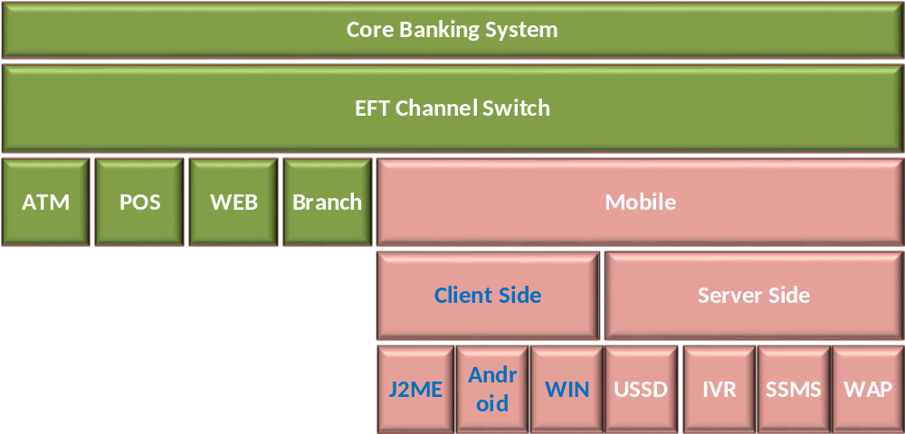
Figure 1: Mobile Banking in the overall banking architecture.
1.An Electronic Funds Transfer, EFT, or Financial Switch accepts, translates and forwards transactions
from multiple channels to the bank’s core systems. This can sit within the bank or the bank’s third party
processor. 2.Access channel for a consumer from their mobile phone, such as SSMS, WAP, USSD2, etc.
The mobile banking channel can be delivered to the consumer through two bearer or application environments.
Client-side applications are applications that reside on the consumers SIM card or on their actual
mobile phone device. Client-side technologies include J2ME and Android. Server-side applications are developed on a server away from the consumer mobile phone or SIM card. Server-side technologies include USSD2, IVR, SSMS and WAP. The bank would only need to select one of these bearer13 channels, or bearer channel strategies,
for implementation. However, in some markets it would be wise to implement more than one bearer channel in order to manage consumer take up and the risk associated with non-take up of a specific technology. The selected bearer channel does not have an effect on where the mobile banking platform should sit.

3.2. Levels of Mobile Banking Platform Implementations
The extension of the payment franchise to mobile can be as simple as a bank channel enablement or as complex as a complete bank system implementation depending on what infrastructure already exists, and that which can be re-used as part of the implementation.

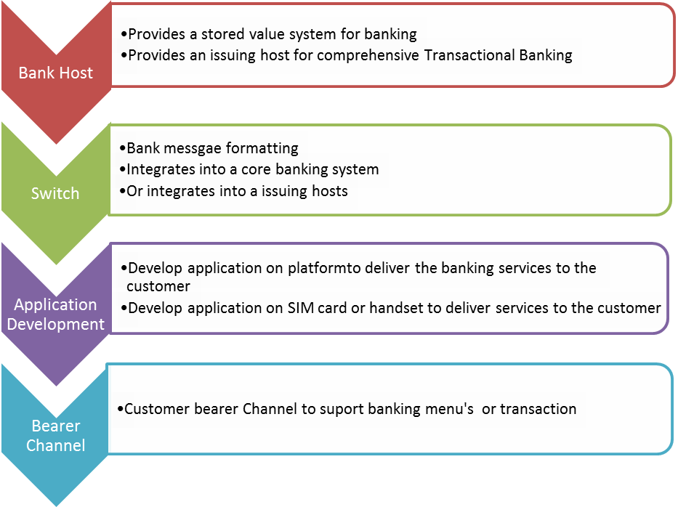

3.3. Mobile Banking Platform High Level Architecture
If we look at a typical bank as one that already has a core banking system, then the mobile
Banking platform that the bank would use, or integrate with, would have the following
Components:

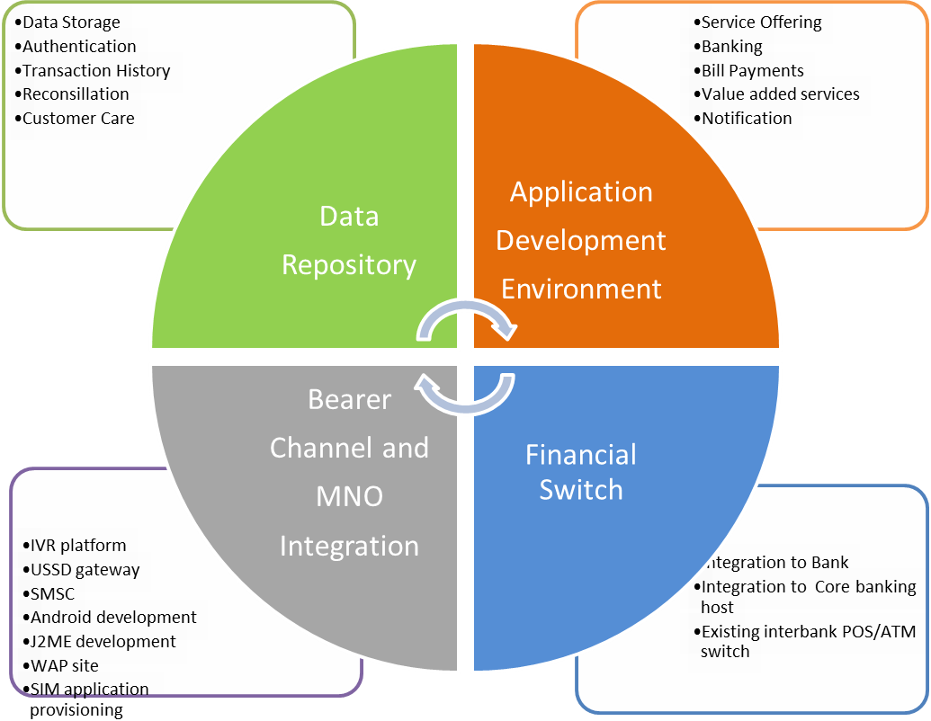
Fig 3. Components of a Mobile Banking Platform

The diagram above reflects a typical mobile banking service. The service would require integration into an MNO to facilitate the usage of the network’s bearer channels and in order to access the consumer’s mobile phone.
The Data Repository stores enough customer information, to facilitate the processing of
financial transactions. The data repository would also house sufficient information to authenticate the customer in each transaction. By housing transactional and consumer data, the repository would also facilitate customer care, and the reconciliation of certain financial transactions that use the application development environment to fulfil services. E.g. selling airtime would require reconciliation between the transactions processed and the airtime loaded
by the network operator. The Application Development Environment facilitates the actual service development to the
consumer, such as banking menus and commands. It may house the integration of third parties in supporting value added services such as bill payments or airtime sales. The application development environment fosters the intelligence delivered to the consumers handset, whether client or server side.

The Financial Switch would act as the interface to the bank’s core banking system. Instructions
collected by the application development environment through the MNO interface, and using data
from the data repository, are translated through the financial switch into a transaction format that the
bank can use.

4. Mobile Banking Subsystem descriptions
This section describes the different components external or internal or vendor products or consumer-facing Mobile Banking Technologies. This component of the end-to-end mobile banking value chain is typically supplied or customized by either a mobile banking vendor or the specialized technology unit within a bank.

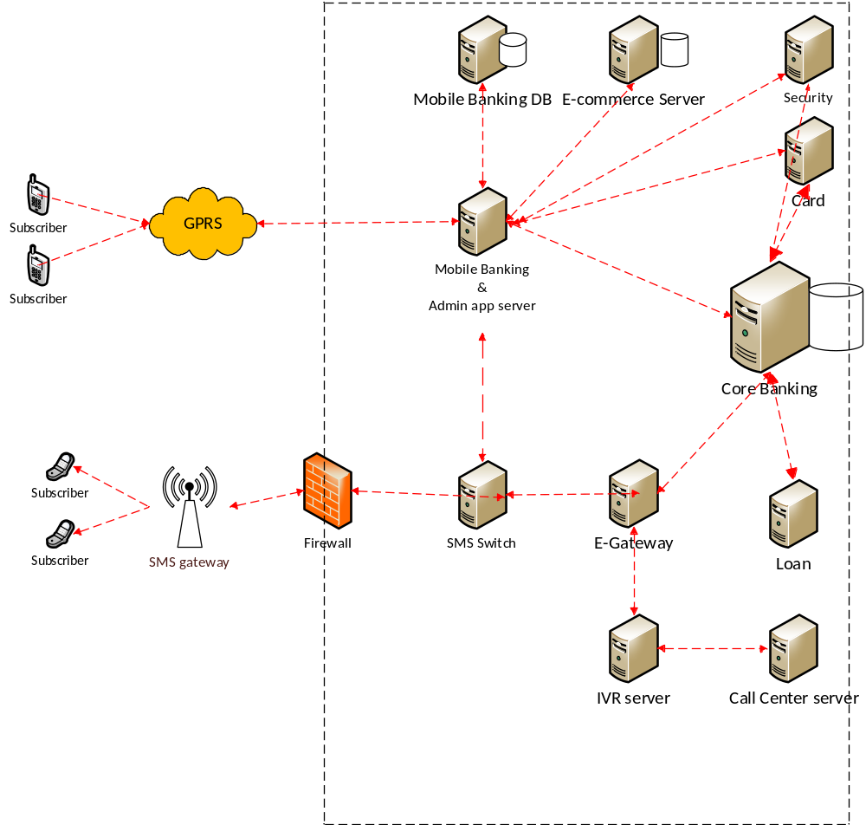

4.1 Mobile handset
Any mobile handset with ability to work in all types of network/handsets, for e.g. GSM, CDMA, USSD/NUUP, Android, Windows, Symbian, RIM-based systems. Also, a tablet with similar hardware configuration can connect to internet and have mobile data connection will be considered as a mobile handset.

4.2 Mobile Application Server
It is a physical hardware infrastructure which hosts the core mobile banking application and Admin application. Any request from user’s mobile is received by the application hosted here. Also the Admin’s control panel used for different reports and analytics are hosted here.

4.3 Mobile Database Server
The independent database to maintain the mobile banking specific data. Mobile banking application server interacts with this database.

4.4 SMS Gateway
An SMS gateway allows a mobile/computer to send or receive Short Message Service (SMS) transmissions to or from a telecommunications network. Most messages are eventually routed into the mobile phone networks. Many SMS gateways support media conversion from email and other formats.
4.5 Firewall
In computing, a firewall is a network security system that monitors and controls the incoming and outgoing network traffic based on predetermined security rules. A firewall typically establishes a barrier between a trusted, secure internal network and another outside network, such as the Internet, that is assumed not to be secure or trusted. Firewalls are often categorized as either network firewalls or host-based firewalls. Network firewalls filter traffic between two or more networks; they are either software appliances running on general purpose hardware, or hardware-based firewall computer appliances. Host-based firewalls provide a layer of software on one host that controls network traffic in and out of that single machine
4.6 SMS Switch

SMS (Short Messaging Service) allows users to send and receive text messages on a mobile phone using the numbered keypad on the handset to input characters. Each message can be up to 160 characters long and sent to and from users of different operator networks. All mobile phones available today support SMS. Indeed, SMS has become a global phenomenon, with billions of text messages sent worldwide every week. It is estimated that a worldwide total of 1 trillion text messages were sent in 2005. In addition to the person-to-person SMS, a large variety of content-based text messaging services are available. The majority of GSM operators offer users the ability to subscribe to
services that send news, sport and entertainment content direct to a mobile phone in the form of an SMS.14
SMS Banking requires a registered customer to initiate a transaction by sending a structured SMS (SSMS) message to the Mobile Banking Service. This SSMS requires a tag word identifier to instruct the SMS gateway to submit the message to the correct SMS application. A tag word is the first word in the SSMS. The balance of the SSMS would hold the instruction from the customer to the Mobile Banking application.
E.g.: ‘bank_balance_PIN’ for a sms based bank balance enquiry;
or
bank_transfer_cheque_savings_100.00_PIN’ for a transfer from a cheque account to a savings
account of an amount of 100.00.

In each of these examples the SSMS would be sent to a SMS short code or address (a shorter version of a phone number). The SSMS would pass from the consumer’s handset through the GSM Network to the MNO SMSC (Short Message Service Centre). A SMSC stores and forwards the SSMS to the SMS Gateway allocated to the short code used by the Mobile Banking Service Provider. The Mobile Banking Service Provider would use the consumer’s mobile number, forwarded by the SMSC with the SSMS, to identify the consumer and respond to the consumer’s request.
The response would follow the same return path and, in the examples given above, would respond to the consumer with an SMS confirmation message. E.g. ‘Bank Balance 150.00’ or ‘Transfer from cheque to savings of 100.00 successful’.

4.7 E Switch
It is kind of router or gateway to which interact with the other banking system like core banking, IVR System Mobile banking system. It runs in a hardware infrastructure and application with interact with the other component of banking and mobile banking system.

4.8 Core Banking System

Core banking is a banking service provided by a group of networked bank branches where customers may access their bank account and perform basic transactions from any of the member branch offices.

Core banking is often associated with retail banking and many banks treat the retail customers as their core banking customers. Businesses are usually managed via the Corporate banking division of the institution. Core banking covers basic depositing and lending of money.

Core banking functions will include transaction accounts, loans, mortgages and payments. Banks make these services available across multiple channels like automated teller machines, Internet banking, mobile banking and branches.[1]

Banking software and network technology allow a bank to centralise its record keeping and allow access from any location.

4.9 IVR Server
In telephony, interactive voice response, or IVR, is a phone technology that allows a person, typically a telephone caller, to select options from a voice menu and interact with the phone system. A pre-recorded voice prompt is played and the caller presses a number on a telephone keypad to select an option, i.e. "press 1 for yes, press 2 for no". Speech recognition can also interpret the caller's simple spoken answer such as "yes", "no", or more complex words, sentences and business names, or a number as a valid response to the voice prompt. DTMF signals (entered from the telephone keypad) and natural language speech recognition interpret the caller's response to voice prompts.15 IVR is the oldest form of consumer-facing mobile banking technology. IVR has been used prior to the existence of mobile phones in the form of telephone banking and is still in use today. IVR requires a registered consumer to make a call to a published telephone number and be answered by a pre-recorded voice that presents various menu options to the consumer. The IVR system would then take the necessary instructions from the consumer by recording the tones of the number selections that the consumer enters on the key pad, or through spoken commands, and creates an instruction that is given to the service provider/bank. The service provider would use the consumer’s mobile number forwarded by the network operator to identify the consumer and as a factor of authentication.

The channel can be used by any mobile device and any consumer capable of making a call. The service provider is required to have an IVR system which can cost as little as US$7000.00 However, it can also scale up to be fairly expensive depending on the number of customers that need to be served. IVR systems are user friendly but may

14 www.gsmworld.com

Prove expensive to maintain and expensive to the consumer who needs to make what can be a relatively lengthy call. Of course, this is dependent on who pays, depending on whether it is a free phone number or not.

4.10 Call Centre System
Call Centre System is system connected to the IVR system to log the customer’s complain. Have the privilege to take action for user’s request. The can generate the issue related ticket(s) or can guide the customer for the better experience of service.
4.11 Ecommerce systems
The subsystem which can be accessed through the mobile banking system where user can do the online shopping.

4.12 Card System
The card subsystem which actually is used to track the user’s credit card or debit card activity. Through mobile banking subsystem user can tack the card, pay the bill , generate the statement, block the card.
4.13 Loan System
The loan subsystem which manage, track or maintain user’s loan, user can apply for loan, track the loan. Through mobile banking you can interact to the loan sub system.
4.14 Bill Payment System
Bill payment sub system manage and maintain the biller, user can add, list delete new biller. Mobile Banking interface can interact this mobile banking sub system.
4.15 Security System
This sub system maintain the user’s security credential like read only , read-write , privilege to access other sub system.

5. Use case diagram
The use case diagram of mobile banking system is given below

